Ex. No.: 5
Date:

AIM:

SELECT with various clause – WHERE, pattern matching

To view the records from the tables using SELECT commands with WHERE Clause and Pattern matching.

DESCRIPTION:

The SELECT statement is used to retrieve data from one or more tables in a database. It allows users to display specific columns or all columns from a table. The retrieved data is known as the result set.

In the Employee Database, the SELECT statement is used to display employee details such as Employee ID, Employee Name, Phone Number, Department, Account Number, and Department ID.

SELECT:
SELECT column1, column2, ...
FROM Employee
WHERE condition
ORDER BY column_name;

The SELECT statement consists of the following clauses:
- SELECT – Specifies the columns to be displayed.
- FROM – Specifies the table from which data is retrieved.
- WHERE – Filters the records based on a condition.
- ORDER BY – Sorts the result in ascending or descending order.
- GROUP BY – Groups rows with similar values.
- HAVING – Filters grouped records.
- LIMIT – Restricts the number of rows returned.

LIKE:
- The LIKE operator is commonly used to select data based on patterns. Using the LIKE operator in the right way is essential to increase the query performance.
- The LIKE operator allows you to select data from a table based on a specified pattern. Therefore, the LIKE operator is often used in the WHERE clause of the SELECT statement.
- MySQL provides two wildcard characters for using with the LIKE operator, the percentage % and underscore _ .
- The percentage ( % ) wildcard allows you to match any string of zero or more characters.
- The underscore ( _ ) wildcard allows you to match any single character.

Questions:

WHERE:
- The student counselor wanted to display the registration number, student name and date of birth for all the students.
- The controller of examinations wanted to list all the female students
- List the Students who registered for the “C001” course.
- Display all faculty details joined before “November 2014”
- Display all the courses not allotted to hall ‘H001’

LIKE:
- List the students whose name ends with the substring “sh”
- Display all students whose name contains the substring “sh”
- Find all the students who are located in cities having “Sal” as substring
- Display the students whose names do not contain six letters.
- Find all the students whose names contains “am”.

OUTPUTS:
1)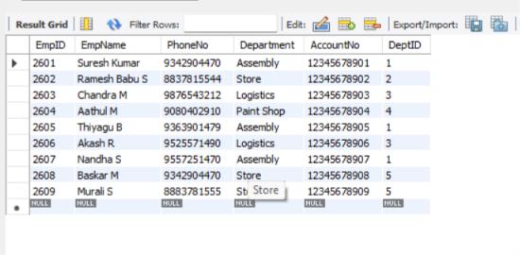

2)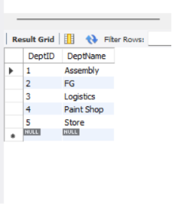

3)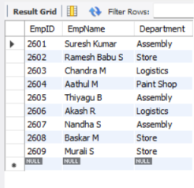

4)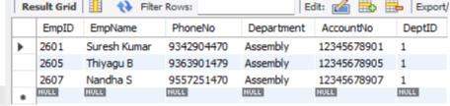

5)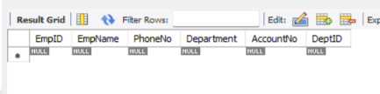

6)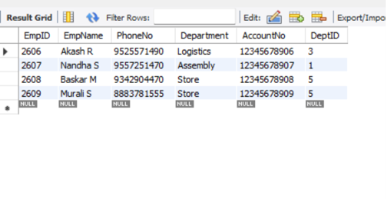

7)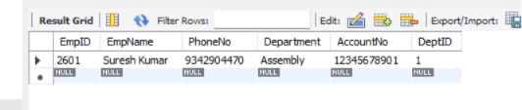

8)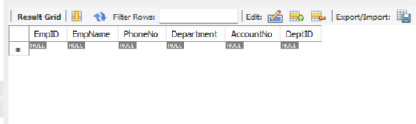

9)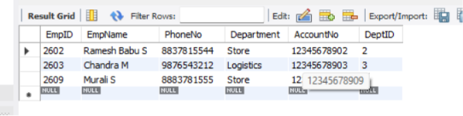

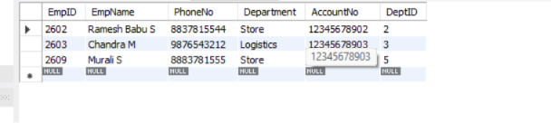

10)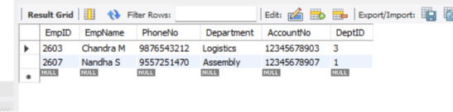

RESULT:

The records from the tables are displayed using SELECT commands with WHERE Clause and Pattern matching.

